



SC&D LAB REPORT
_{NAME:}
_{Muhammad Shameel}
_{Sap Id:}
₅₅₅₇₉
_{Section:}
_{SE (5-2)}

1
Code:

void main() {
print('Muhammad Shameel!');
}

Screenshot:
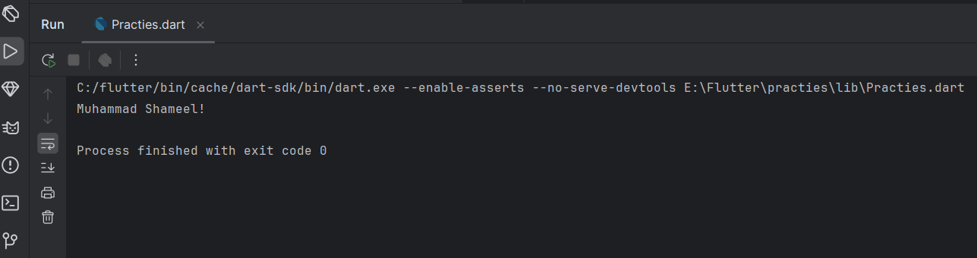

2
code
void main() {
// Let's declare some variables
String greeting = 'Hello'; // Holds text
String name = 'Muhammad Shameel';
int age = 21; // Holds whole numbers
double height = 5.11; // Holds decimal numbers
bool isProgrammer = true; // Holds either true or false
// Let's print them out
print(greeting);
print(name);
print(age);
print(height);
print(isProgrammer);
// We can combine text and variables using string interpolation: $
print(
'$greeting, $name! You are $age years old and $height meters tall. Are you a programmer? $isProgrammer');
}

screenshot:
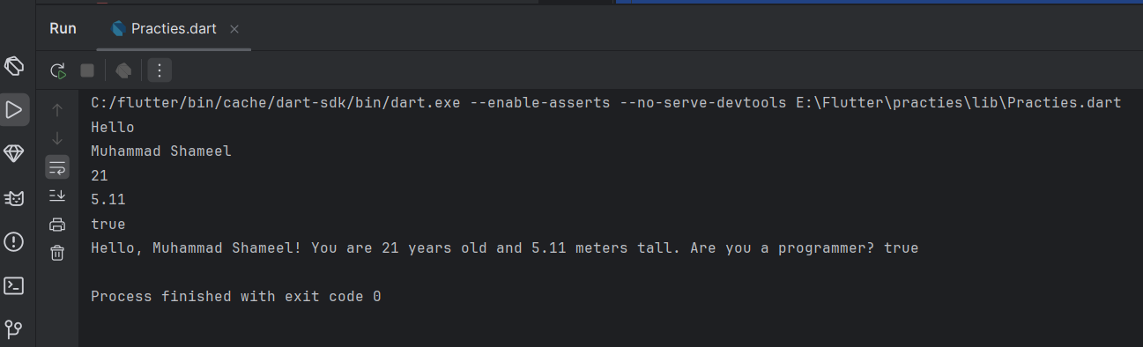

3
code
import 'dart:io';
void main() {
String name = 'Muhammad Shameel';
stdout.write("Enter your age :");
int votingage =int.parse(stdin.readLineSync()!);
if(votingage>=18)
{
print ("$name can vote " );
}
else
{
print("$name cannot vot yet");
}
}
screenshot
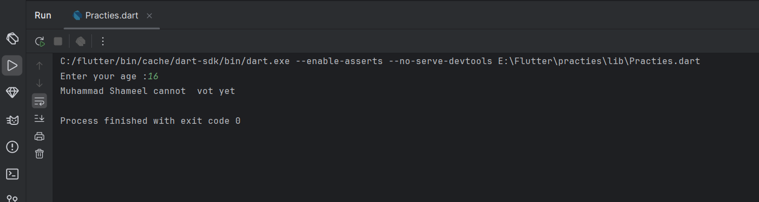

4
Code:
void main() {
// A simple for loop
print('Counting to 5:');
for (int i = 1; i <= 5; i++) {
print(i);
}
}

Screenshot:
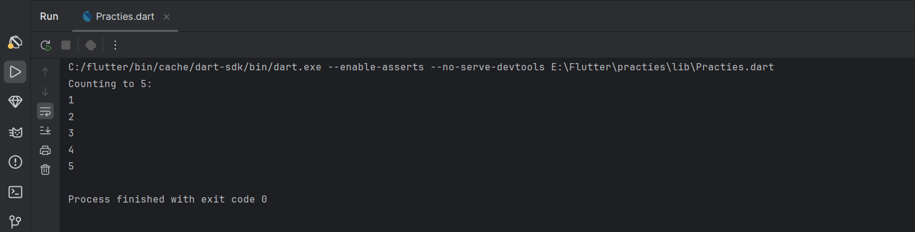

5
Code:
void main() {
// Create a list of fruits
List<String> fruits = ['Apple', 'Banana', 'Mango'];
// Print the whole list
print(fruits);
// Print each fruit one by one using a for-in loop
print('My favorite fruits:');
for (String fruit in fruits) { // For each fruit IN the fruits list...
print(fruit); // ...print the fruit.
}
print('The first fruit is: ${fruits[0]}');
print('The second fruit is: ${fruits[1]}');
}

Screenshot:
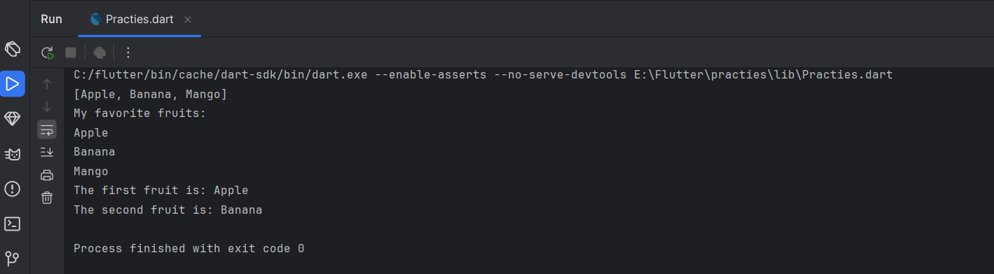

6
Code:
void main() {
// 1. Variables
String appName = 'Dart Learner ';
int year = 2025;
List<String> features = ['Variables', 'Loops', 'Lists', 'Logic'];
// 2. Print a welcome message
print('Welcome to $appName!');
print('This program was made in $year.\n'); // \n adds a blank line
// 3. Loop through features
print('Today you will learn:');
for (String topic in features) {
print('- $topic');
}
// 4. Make a decision
print(''); // Blank line
bool isExcited = true;
if (isExcited) {
print('You are excited to learn Dart! 😀');
} else {
print('You will be excited soon! 😊');
}
}

screenshot:
